Vancouver Island Minor Lacrosse Commission
Regular Meeting Minutes
March 30, 2026

Attendees
Voting Executive
Chair Andy Stuart
Vice Chair Scott Barillaro
Secretary Krista Gregory
Treasurer Michelle Vecqueray
Zone 6 Representative Adam Gow
Web Master/Scheduler Liaison Jeremy Penzin
Female Coordinator Kate Blass

VIMLC Executive
BCLOA Representative Sarah Dmytruk
Indigenous Development Bryan Baxter (absent)
BCLCA Representative Kelly Fines
Commissioners Cathy Coulson, Greg Toll, Penelope Barillaro, Mike Bisgrove, Ken Passmore, Alicia Hayes

Association Representatives
Alberni Valley Jeremy Penzin
Campbell River Sarah Thomas
Comox Valley Chad Robinson
Cowichan Valley Janice Parmar
Juan de Fuca Kyla Pedlow, Nikila Cyr, Curtis Morwick
Nanaimo Bryan Norby, Shawn Swanson
Oceanside Ryan Minty
Peninsula Simon Upshon, Terry Hall
Saanich Doug Anderson, Katherine Dyrland
Victoria Esquimalt Kate Blass, Stacey Santos

- Call Meeting to Order 7:07 pm
Land Acknowledgement, Sarah Thomas

- Adoption of Previous Minutes
Motion made by Kyla Pedlow, seconded by Janice Parmar, Carried

- Additions and Adoption of Agenda
- Motion made by Scott Barillaro, seconded by Sarah Dmytruk, Carried

- Business Arising from the Minutes none

- Financial Report: Michelle Vecqueray
Current Bank balance is $25,328.92
There are no outstanding bank items.
I am happy to confirm that we are now set up to pay by E-transfer, which will make paying officials at playoff time much easier!
Attached is the Budget vs Actual statement as of March 2026.
Invoices were emailed out to presidents March 18th. Thank you to the 4 associations that have sent in payment for their first half dues. To the remaining associations please arrange to have payment sent in as quickly as possible. Please let me know if you require me to send the invoice out again or if it should be sent to another association contact.
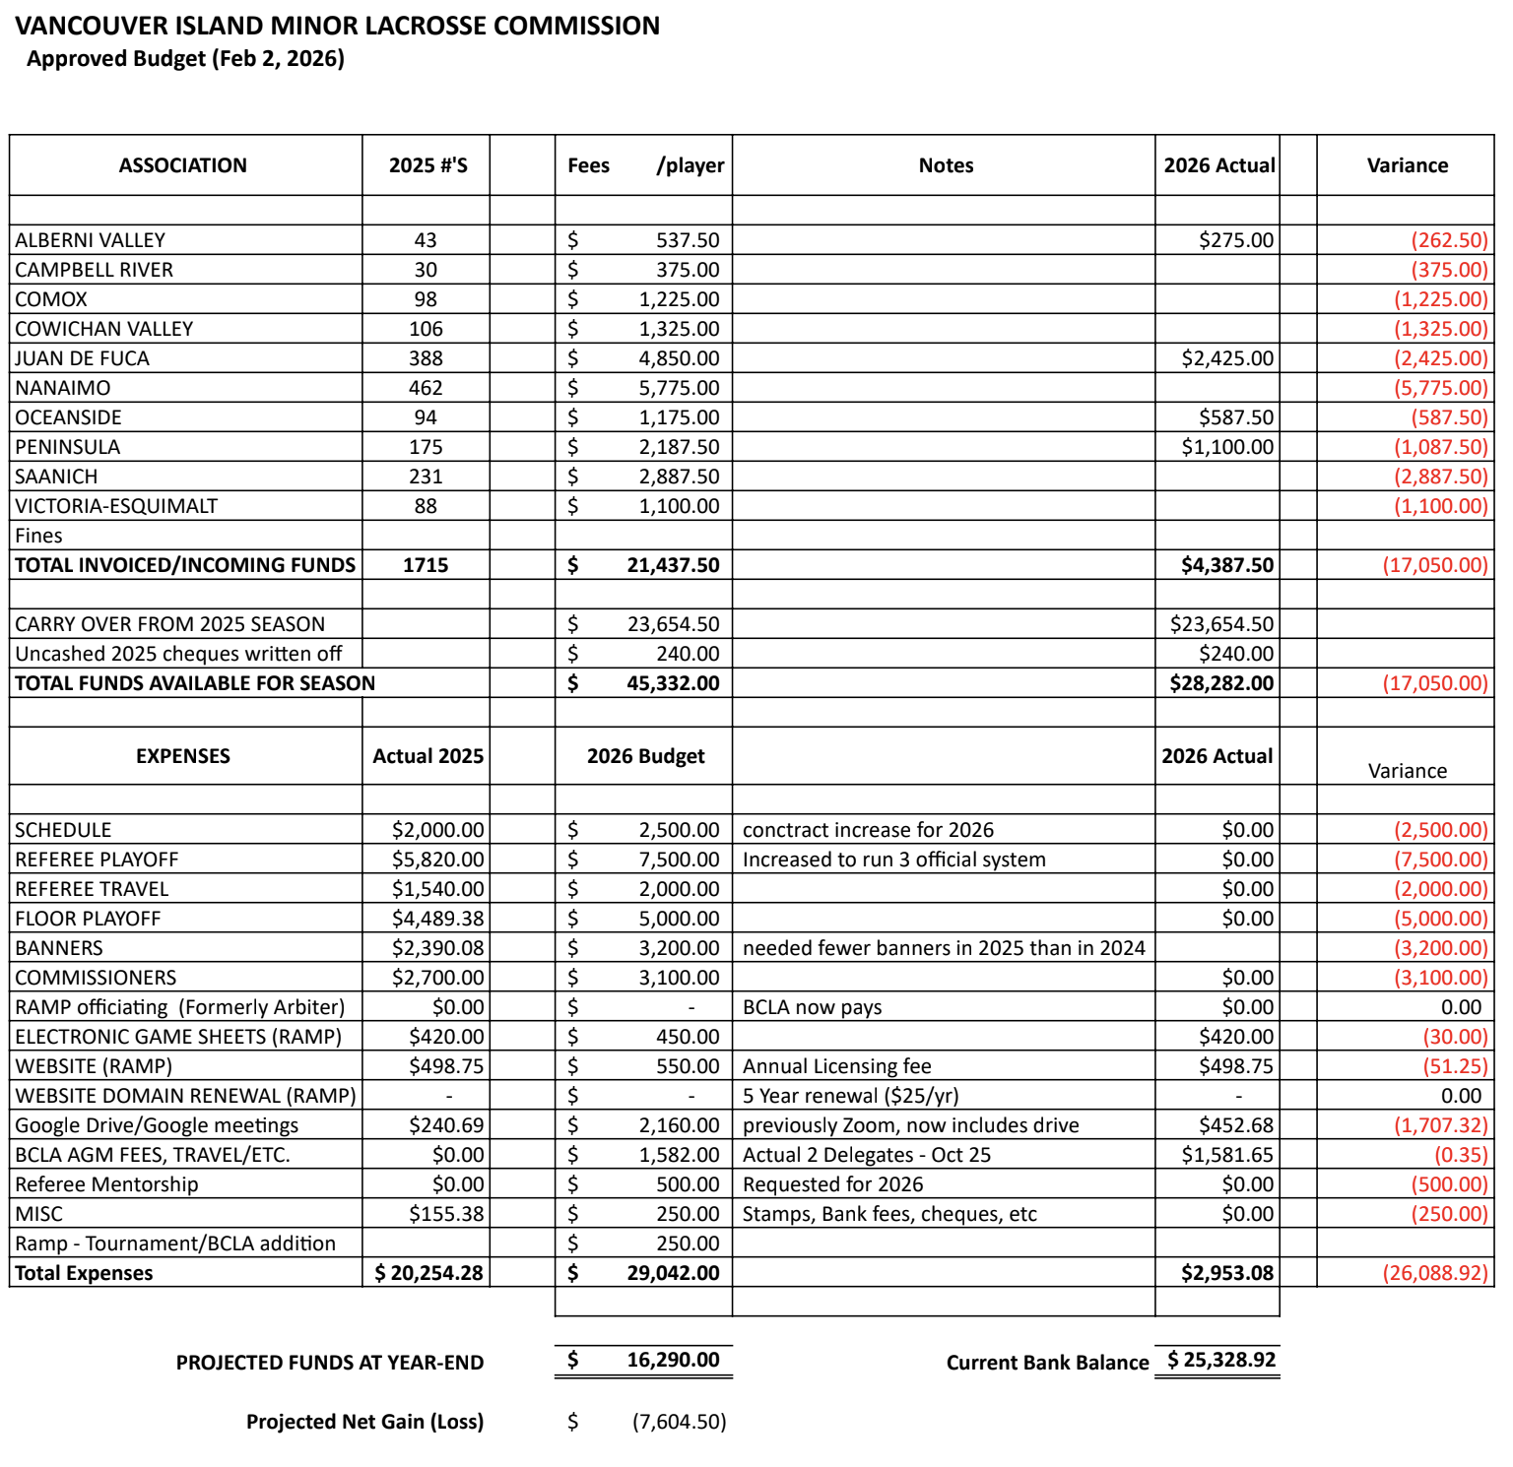

- Zone 6 Reports
- Chair Andy Stuart
1. Carryover Suspensions - List being published Shortly by MD. Was delayed as some Commissioners failed to submit last year.
2. Oversized Rosters Approved:
- Peninsula's U15 & U17
- VELA U15 and U22 Female
- Comox U11 & U15
3. Combo Teams Approved:
- Saanich & VELA at U11
- Campbell River & Comox at U13
- Alberni & Oceanside U13 and U1
4. No Playdown Requests from Junior to Minor for VIMLC
5. Coach Clinics Delivered
- March 14, Level 2, facilitated by Brian Baxter, hosted by VELA, 19 participants
- March 28, Level 1, facilitated by Cody Cook, hosted by JDF, XX Participants
- Mar 29 Level 1, facilitated by Kelly Fines, hosted by Oceanside, 13 participants
6. BCLA Town Hall, April 11 in New Westminster & Virtual Option https://bclacrosse.com/2026-bcla-townhall.php, Register HERE: https://forms.gle/THX1XAEW8ucJDp1v8
7. BCLA Governance Training is hosting two Governance sessions for any and all members who would like to hear more about what Governance is and how proposed new bylaws that are in compliance with the BC Societies Act are the foundation for governance success within the BCLA.

Governance Workshops - Zoom Registration Links
- Governance Primer Workshop - March 31 2026 - 6:30-8:00pm
- Governance Primer Workshop - April 2 2026 - 12:00-1:30pm
- Minor Directorate Rep Adam Gow
MD met on Saturday. Officials chair has stated if any new rules are a major issue this season with game functionality there is a possibility for them to be reviewed and reverted. This could be a mid-season thing but also could not happen and may occur post season. The ref training package made by our BC officials’ group is being used nation-wide as the training standard, so BC is leading the way!
It’s been urged for associations to let their parents know to be patient with the new rules. Player/coaches/officials all learning the new stuff together and there is bound to be hiccups. Dallas has created a summary of key changes. We are looking for a digital copy which can be shared on our VIMLC site and be accessible for parents to learn new rules at a glance. The full rules are available on the BCLA site including BC exemptions.
The female chair has reached out to ask if any association knows why they have a mass drop off from U17 to U22. Thought was maybe due to contact rule changes or just life.
Carryover list should be up March 30. It was recommended to check names not just associations. Turned out last year a coach had moved clubs and was active on the bench while he should have been serving. This could also affect out of zone release players coming here for academy teams or players moving in the off season.
BCLA is in their 3rd draft of the governance rules and should be nearing final completion soon. Andy has stated the information sessions coming up.
The LMMLC is willing to host our commissioners on the RAMP system. TBD next week. This will be very helpful especially with inter zone play in competitive divisions.
Tourneys go live Monday. To echo BCLA message teams are asked not to apply for every tourney if they do not intend on going. It puts a huge strain on hosts if/when teams pull out after being accepted. We have seen this firsthand in Peninsula and their requirement to cancel tourneys/modify and unable to recoup costs incurred.
Like U5 the question of associations hosting U21 has been asked as the new CL rules go up to U21. If enough interest it would be brought up at the AGM. It is an active league in Ontario, mirroring somewhat what intermediate used to be. It would be a minor team not senior. Just before covid a U19 league idea went to the AGM and was very unwelcomed by the senior (includes junior) teams. If this came to be it would directly affect/compete with Jr B tier 1 and 2 teams for players.
Summer Games application deadline is April 16, on the BCLA site. It is open to all U17 players. Per the Games rules players can only be on one Summer Games team. Please encourage your U17 coaches to pass information onto their players.

- Vice Chair Scott Barillaro
The main focus the last four weeks has been on building, reviewing, formatting and posting the league schedule in stages. The U11A through U17 schedule went up first and we worked through a few hiccups since it was Jeremy's and my first time doing it. Steph Prizeman came out of retirement to help us. Thanks to those who reviewed their teams' schedules and provided corrections. I think we have addressed most of them. I need to review specific feedback from one division but I think we're in pretty good shape for next weekend.

The U11B North and South schedule was posted last night. I received some feedback last night and checked a couple of teams this morning. It appears that the home games for U11 South loaded properly, but the away games did not. I am working with Jeremy and the scheduler to address this. This is a data entry issue because the base spreadsheet reviewed by associations has the correct dates and times. We will sort this out ASAP.

The scheduler is currently working on U7/U9 South using the usual game rotations. I sent a note to U9 North presidents over the weekend to confirm the approach. We used a hybrid last year where Oceanside played in Nanaimo on Friday nights and Nanaimo hosted some jamboree days allowing North Island teams to come down and play doubleheaders. I suspect we will look at something similar for U7 North.

We are still waiting for the Female Interlock from the Lower Mainland. Kate likely has more to report on this. In the interim, I asked the scheduler to find times for female teams to start playing during the first two weeks of April. We may extend this to the third week subject to what we hear from the LMMLC.

Here are some early takeaways:
- This process is much more time consuming than I anticipated, even with the contractor. Steph did a lot of heavy lifting behind the scenes to make this work.
- The reduction to 12 games (except for U11B and U15B which got 14) was mostly offset by the increased number of teams and the addition of the U11A division. A handful of games remain unscheduled.
- Some local governments adjusted association contracts after submission. The scheduler took this into account when it happened early enough. It's more an observation that competition for floor space has increased due to ball hockey, roller derby and other indoor sports.
- There is no standard definition of "review" when the draft schedule is sent out. This leads to different levels of rigour across associations. This should be considered as part of the 2026/27 Business Rules.
- There also appear to be different interpretations of how blackouts work. Clarification would be helpful for associations and the scheduler. This should be considered as part of the 2026/27 Business Rules.
- A season typically has 10 Saturdays and 10 Sundays. The number of days decreases further due to various blackouts. The Commission may need to set one league-wide blackout date for all associations to make scheduling more predictable. This should be considered as part of the 2026/27 Business Rules.
Start of Season Game Change Reminder

I received questions about game changes resulting from low player numbers over the Easter Weekend. Easter moves around the calendar from year-to-year but the league schedule always starts the first weekend of April for U13, U15 and U17. Here are the game change guidelines from the Business Rules in any case you receive questions.

1. Rescheduling Games

The VIMLC recognizes conflicts can arise during a season and reasonable requests to reschedule can occur.

Reasonable requests include:

• Attending a BCLA or VIMLC sanctioned event.
• Extreme weather, road closure(s), or other public health and/or safety emergency that makes travel dangerous.
• Other compelling rationale deemed sufficient by the responsible Commissioner.

Reasonable requests do not include:

• Lack of players due to illness, injury and/or other commitments.
• Lack of coaches due to illness, injury and/or other commitments.
• Association activities and/or events that are not covered by a blackout request.

Associations are expected to manage roster challenges using existing tools (i.e., player call ups, assigning a qualified coach from another team, etc.).

I will continue to provide updates as we complete different stages of the schedule.

- BCLCA Rep Kelly Fines
not much to report other than I hosted a level1 clinic today (Sunday) in Oceanside. We had 12 coaches go through the course.

- BCLOA Rep Sarah Dmytruk
As of right now we have wrapped up the in class clinics for officials on the island and we are currently working on getting a couple more floor clinics arranged to capture the last group of officials who didn't make it to a floor session yet. Our numbers are looking great this year for EL and L1 but we are still definitely lacking in L2 officials. For those of you who are unfamiliar with the officials ranking system, EL is our brand new kids, typically 13 or 14 years old, who will cover U7, U9 and U11 on floor and then the shot clock. L1 is going to be our second and third year officials who will cover up to U13 on the floor, maybe a few of them will get U15 by the end of the season. And then we have our L2 officials who are usually 18+ years old and are covering anything from U13 up to U22 female.

I'm sure you have all heard in the past from Tyler Boyer, we need to work on getting more adults to step up and officiate. Ex Junior players are always great to have come and officiate because they are already very familiar with the game and can really help out the young officials. We have finished the in person class sessions but if any of the presidents out there know of any stragglers who missed registration or Jr players who would like to officiate this season, send me an email and I might be able to work something out.

Games are starting up this coming weekend and I know everyone is super excited to see the new rulebook in action but I can't stress enough that we need to have patience with our officials as they are going to be facing a major learning curve with this as well as the coaches and players. If anyone requires clarification on a rule or has any concerns regarding something that happened in a game, please don't hesitate to reach out to myself or your association's head ref.

- Indigenous Development Coordinator Bryan Baxter
Nothing to report

- Female Coordinator Kate Blass
Not much to update, just waiting on the lower mainland to finalize the schedule.

- Web Master Jeremy Penzin
A lot to learn from with RAMPs new web-based platform that I'm working through the learning curve with Scott and Stephanie. Scott's report highlights where we are at with the scheduling process and how it's flowing into RAMP and proofread by the commissioners. Thank you to everyone so far for catching errors.

BCLA has now standardized the penalties that are entered in to RAMP. I removed all the old penalties and imported the new ones, so all penalties are standard from VIMLC to the lower mainland, provincials, etc. Officials can provide feedback on how looking up penalties flow during a game.

Please keep sending any issues regarding RAMP or VIMLC website over.

- Association Reports
- Alberni Valley
Lots of things going on in preparation of the lacrosse season. We are up to 60 players registered. It's hard to keep up with it all, but hopefully some parents are willing to help fill the gaps that exist on this board.

- Campbell River
Happy to report we have are design phase for our arena project with a proposal of a 3rd arena that should not impact future seasons as they will hopefully just do minor cosmetic changes and focus on the new build. So our arena project shouldn’t impact any future dry floor time if this new proposal passes and we can re focus on rebuilding our association without the dark cloud of no arena floor looming. Which is going to take some great effort.

Thankful to Comox as well for taking on our players again this season and allowing a combo so we can be apart of the mayhem of competitive divisions. It’s been 3 years since we been able to participate in the higher divisions

- Comox Valley
It looks like we will end up with about 130 registered players on eight teams. It's quite a bit more than we were prepared for and we've fallen behind in some areas of administration. We are looking at adding positions to our board for next season to help manage the workload.

We are looking forward to starting the season this weekend and to getting a covered floor when the ice comes out the weekend after.

- Cowichan Valley no report

- Juan de Fuca

We are at 420 registered players including the females we have sent to VELA. We will be hosting a total of 24 co-ed teams this season, which is pretty much our max with our current facilities.

All of our teams were formed prior to Spring Break beginning, with U11-U17 practicing throughout March and U7 and U9 starting this week. Everyone is very excited to get going!

Tournament applications opened this morning. JDF will be hosting the Travis Bateman U11 Tournament, and the Rumble on the Rock U13 Tournament. So far we have had a lot of applications come through, and we look forward to getting teams confirmed sooner rather than later.

We’ve been busy getting our referees certified and trained. We’re heading into another season of strong numbers for our referee pool, which is great!

Looking forward to the season start this weekend!

- Nanaimo no report

- Oceanside
We are off to the races. We had non mandatory practices all of March for all ages. Our registration total is at 106. So we are growing. We will be starting a development practice that will be extra each week for any players that are wanting that extra knowledge and practice time April 12/26.

Our combo u17 team with port Alberni will be lead by Darren Manix. Wearing port uniforms. With an Oceanside manager and u13 combo with port Alberni will be lead by Dale Darby. Wearing Oceanside uniforms with port manager. There will be one practice in port Alberni and one at Oceanside a week. The financials for floor time ie practices and games. Will be split evenly amongst the rostered players.

All coaches and managers are all in place for all teams. All applying for tourneys and are all very exciting to get the season started.

- Peninsula
We had our Coaches/Managers meeting last night and have filled all roles on all teams other than one team manager. We started with twelve teams and due to unforeseen circumstances had to change to eleven teams kind of late so apologies to the scheduling team for that.
We are around 190 registrations currently which is up from 176 last year so the hard work to grow the game has continued to bear fruit.
You can feel the excitement from kids and families growing as we get closer to games beginning so looking forward to a great season ahead.

- Saanich
We are sitting at 247 registrants including our female players playing in VELA (including my daughter which I am very excited about). That is a 7% increase over last year but within the Association's ability to manage with existing box and floor time.

We formed our U11 through U17 teams in February. Most teams in these age groups started practicing in March when the weather cooperated. We just confirmed team staff for our U7 team. They will start practicing next week. We lost some coaches in U9 due to players not returning so we are still recruiting some new volunteers. U9 will hold combined skills and drills/mini assessment this week and will form the three teams next week after we balance them out as much as possible.

The administrative and business side is working reasonably well. Our online store is paying dividends in terms of inventory management and payment tracking. Our player fee collection has been easier overall this year as well. We recently received direction on how we can manage one-year player transfers between associations using RAMP Registration without processing mass player releases. We will sort that out this week.

Overall, I think we're as prepared as we can be at this point. However, the first 2-3 weeks are always a bit crazy no matter how much preparation we put in.

- Victoria Esquimalt no report

- Commissioner Reports
No reports at this time

- New Business

A. 2026 League Schedule

U7 and U9 north schedule structure still being finalized, will likely be jamboree style with various hosts. Presidents please confirm with Scott Barillaro what you prefer.

B. 2026 Female Interlock Schedule

Work is continuing with the LMMLC to complete this schedule.

C. Coaches & Officials Clinics

BCLA has decentralized the organization of clinics, so the VIMLC has taken over. Three coaching clinics have already taken place, and one more level 1 is planned as well.
There will also be one more officials clinic, please let Sarah know if you have anyone who needs to register.

D. Governance Sessions - March 31 & April 2
Intended to help associations to understand the governance of a non profit under the BC Societies Act. Will be facilitated by Andy Stuart.

E. BCLA Townhall - Bylaws on April 11

This meeting will be the unveiling of the draft of the new BCLA bylaws. The intention is to be more in compliance with the Societies Act.

F. Commissioners

The role of commissioner can be difficult and time consuming, and finding people willing to take on this job can be challenging. Presidents are asked to ensure that communications with them are always respectful (ie coaches and managers, who are the only ones who should be contacting commissioners).
Also note, all exhibition games must be approved by commissioners, but scrimmages within an association do not need approval.

G. Summer Games
Registration closes April 16, through the BCLA. Evaluation floor time costs are technically the responsibility of the association, but next meeting we will discuss having the VIMLC pay this cost.

  - Discussion: BCLA MD Rule change adaptations
Discussion about about what we can do to ensure information about rule changes are communicated to coaches, managers and fans. Ideas presented include signs in arenas with a QR code linked to BCLA website, mandatory coaches meeting with association head ref, emails to all families from registrar outlining changes, and discussion at parent meetings at the beginning of the season.

- Next Meeting: Monday, May 4 at 7 pm

- Motion to Adjourn
Motion made at 7:56 pm by Andy Stuart, seconded by Krista Gregory, Carried

